# A MINI PROJECT REPORT ON

**Tracking Air Pollution with Sentinel-5P Imagery: NO₂ Monitoring in Google Earth Engine**

A Report Submitted in Partial

Fulfillment of the Requirement for the

Award of the Degree of

**MASTER OF TECHNOLOGY**

**IN**

**ENVIRONMENTALGEOMATICS ENGINEERING**

**By**

**HAFSA FATHIMA(24011D6014)**

**Under the guidance of**

**Dr .T.VIJAY LAXMI .**

**Professor of ENVIRONMENTAL GEOMATICS**

**JNTUH University College of Engineering Hyderabad**



DEPARTMENT OF ENVIRONMENTAL GEOMATICS

JAWAHARLAL NEHRU TECHNOLOGICAL UNIVERSITY

COLLEGE OF ENGINEERING, SCIENCE AND TECHNOLOGY HYDERABAD-500085, TELANGANA, INDIA

2025

**DEPARTMENT OF ENVIRONMENTAL GEOMATICS**

**JAWAHARLAL NEHRU TECHNOLOGICAL UNIVERSITY**

**COLLEGE OF ENGINEERING, SCIENCE AND TECNOLOGY HYDERABAD HYDERABAD-500085**



**CERTIFICATE**

This is to certify that this Report entitled “Tracking Air Pollution with Sentinel- Imagery:NO₂ Monitoring in Google Earth Engine” , submitted by HAFSA FATHIMA

**(24011D6014)** in partial fulfillment of the academic requirements for the award of the degree in

**Master of Technology in** with specialization in **environmental geomatics,** is a record of his own research work carried out under my supervision and guidance. The content embodied in this Report has neither been submitted by them nor by anyone else for the award of any degree of diploma.

|  |  |
| --- | --- |
| **Dr. VIJAY LAXMI** | **. DR HIMA BINDU** |
| Professor | Professor & Head |
| Department of ENVIRONMENTAL GEOMATICS | Department of ENVIRONMENTAL GEOMATICS |
| JNTUHUCEST | JNTUHUCEST |
| Hyderabad | Hyderabad |

**DEPARTMENT OF ENVIRONMENTAL GEOMATICS**

**JAWAHARLAL NEHRU TECHNOLOGICAL UNIVERSITY**

**COLLEGE OF ENGINEERING, SCIENCE AND TECNOLOGY HYDERABAD HYDERABAD-500085**



## **DECLARATION**

I hereby declare that the report of the M. Tech. project work entitled **“Tracking Air Pollution with Sentinel-5P Imagery: NO₂ Monitoring in Google Earth Engine** “, which is being submitted to the Department of ENVIRONMENTAL GEOMATICS, JNTUH University College of Engineering, Hyderabad, in partial fulfillment of the requirements for the award of the Degree of **Master of Technology in ENVIRONMENTAL GEOMATICS, Department of Center for Environmental Geomatics Engineering**, is a record of work carried out by us. The material contained in this report has not been submitted to any University or Institution for the award of any degree or diploma.

HAFSAFATHIMA(24011D6014) PLACE:JNTUH UCESTH

Date: 10/09/2025

## **ACKNOWLEDGEMENT**

It gives me great pleasure in expressing my gratitude to **Dr.T.VIJAY LAXMI,** Professor of ENVIRONMENTAL GEOMATICS, Jawaharlal Nehru Technological University Hyderabad, University College of Engineering Hyderabad, for her invaluable co- operation in providing the technical advice and her genuine and sincere efforts in supervising the work. I would like to express my sincere thanks to her careful review of my dissertation research and for her guidance throughout the course of the work.

I wish to express my profound thanks to **Dr.HIMA BINDU**, Professor and Head of ENVIRONMENTAL GEOMATICS department, JNTUH University College of Engineering, for extending the facilities and the cooperation for the successful completion of this work.

I would also like to specially thank my academic faculty **Professor Dr. VAMSHI KRISHNA SIR** Department of Environmental geomatics Engineering

I also express my gratitude to Mr.sangeeta, and Mr.roja non-teaching staff of the environmental geomatics Engineering Laboratory and many invisible hands behind the completion of this work.

**HAFSA FATHIMA (24011D6014).**

5

I

|  |  |  |
| --- | --- | --- |
| S.NO | CONTENTS | PAGENO |
| - | ABSTRACT | I |
| 1 | INTRODUCTION  1.1 BACKGROUND  1.2 OBJECTIVES | 1-3 |
| 2 | LITERATURE REVIEW | 4 |
| 3 | STUDY AREA | 5-6 |
| 4 | DATA COLLECTION | 7-13 |
| 5 | METHODOLOGY  5.1 DATA PREPARATION  5.2 MAPPING  5.3 SPATIAL ANALYSIS  5.4 CRASH FREQUENCY MAPPING | 14-20 |
| 6 | RESULT AND DISCUSSION | 21-25 |
| 7 | RECOMMENDATION | 26 |
| 8 | CONCLUSION | 27 |
| 9 | SOFTWARE USED | 28 |
| 10 | REFERENCES | 28 |
| 11 | APPENDICES | 28 |

**1ABSTRACT**

Nitrogen dioxide (NO₂) is a major air pollutant with significant implications for human health and environmental quality. This study utilizes Google Earth Engine (GEE), a cloud-based geospatial analysis platform, to track and analyze NO₂ pollution trends over time at designated air monitoring stations. By integrating satellite-based remote sensing data (e.g., Sentinel-5P TROPOMI) with geographic coordinates of official monitoring sites, we quantify NO₂ concentration levels across multiple time intervals. The analysis reveals both spatial and temporal patterns of pollution, enabling the identification of long-term trends, seasonal variations, and the impact of policy interventions or episodic events (e.g., lockdowns, industrial shutdowns). GEE’s capabilities allow for near-real-time monitoring, historical data analysis, and scalable visualization, providing a powerful tool for air quality assessment and environmental decision-making. The findings support the development of more targeted air pollution mitigation strategies and contribute to ongoing efforts in atmospheric monitoring and public health protection.

## 1.INTRODUCTION

1.1 BACKGROUND

Nitrogen dioxide (NO₂) is a toxic air pollutant that is part of the nitrogen oxides (NOₓ) family. It is mainly produced by the burning of fossil fuels, especially from vehicles, power plants, and industrial activities. NO₂ is a key indicator of air pollution, particularly in urban and industrialized areas.

NO₂ has both direct and indirect effects on human health and the environment. Short-term exposure can cause respiratory problems such as coughing, wheezing, and shortness of breath, particularly in children, the elderly, and people with asthma. Long-term exposure is linked to chronic respiratory diseases and can reduce lung function. In addition, NO₂ contributes to the formation of ground-level ozone (O₃) and fine particulate matter (PM2.5), which are harmful to both health and the environment.

Environmentally, NO₂ plays a role in acid rain formation and can harm vegetation and aquatic ecosystems. It also contributes to the formation of smog, reducing visibility and air quality.

Because of its importance, NO₂ is regularly monitored by environmental agencies. With recent advancements in satellite remote sensing — such as the European Space Agency’s Sentinel-5P satellite — scientists can now track NO₂ levels globally, allowing for improved monitoring, policy-making, and public awareness

1.2 OBJECTIVES :

1. **Assess Air Quality Over Time and Space**  
   To monitor the spatial and temporal distribution of NO₂ concentrations, especially in urban, industrial, and high-traffic areas.
2. **Identify Pollution Hotspots**  
   To detect regions with consistently high NO₂ levels, helping to prioritize environmental and public health interventions.
3. **Evaluate Human Health Risks**  
   To assess the potential health impacts of NO₂ exposure on populations, particularly vulnerable groups such as children, the elderly, and those with respiratory conditions.
4. **Support Environmental Policy and Regulation**  
   To provide data for the formulation and evaluation of air quality policies, emission control regulations, and sustainable urban planning strategies.
5. **Monitor the Impact of Human Activities**  
   To analyze how activities such as transportation, industry, and energy production contribute to NO₂ pollution.
6. **Track the Effectiveness of Pollution Control Measures**  
   To measure changes in NO₂ levels before and after implementing air quality improvement strategies, such as lockdowns, traffic restrictions, or industrial regulations.
7. **Contribute to Climate and Atmospheric Research**  
   To better understand the role of NO₂ in atmospheric chemistry, including its contribution to ozone and particulate matter formatizzthe effectiveness of technologies like Google Earth Engine and satellite data (e.g., Sentinel-5P) in monitoring air pollution in near real-time.

### 2. LITERATURE REVIEW

Nitrogen dioxide (NO₂) is a key air pollutant, largely from combustion sources (traffic, industry, power plants). It has adverse effects on human health and environment. Satellite remote sensing data paired with cloud‐computing platforms like GEE have become popular for mapping, tracking, and analysing NO₂ spatio‐temporal patterns over large areas.

### Data Sources & Satellite Products

* **Sentinel‑5P / TROPOMI**: Many studies use the Sentinel‑5P mission, especially the TROPOMI instrument, to retrieve tropospheric NO₂ column densities. E.g., “Factors influencing spatiotemporal variability of NO₂ concentration in urban area: a GIS and remote sensing‐based approach” in Gazipur, Bangladesh used TROPOMI via GEE. [PubMed](https://pubmed.ncbi.nlm.nih.gov/39804505/?utm_source=chatgpt.com)
* **Sentinel‑5 (Copernicus Sentinel‑5 Precursor / Sentinel‑5 AP)**: Used for mapping multiple air pollutants including NO₂, CO, SO₂, O₃ etc. For example, studies in Arak, Iran used Sentinel‑5 to monitor NO₂ (and others) via GEE. [MDPI+1](https://www.mdpi.com/2673-4672/3/2/19?utm_source=chatgpt.com)
* **Complementary Data**: In many studies, NO₂ data are combined with other datasets such as LST (Land Surface Temperature), NDVI (vegetation index), land use / land cover (LULC), population density, road/traffic density etc. These variables help explain spatial variability. [PubMed+2PubMed+2](https://pubmed.ncbi.nlm.nih.gov/39804505/?utm_source=chatgpt.com)

### Methods & Analytical Frameworks

* **Time‐series analysis**: Extracting monthly, seasonal, and annual averages of NO₂ from satellite products using GEE, to understand temporal trends and changes. E.g., in Arak city: monthly, seasonal, annual patterns of NO₂ via Sentinel‑5 in GEE. [MDPI](https://www.mdpi.com/2673-4672/3/2/19?utm_source=chatgpt.com)
* **Spatio‐temporal variability and correlation/regression with environmental/anthropogenic factors**:
  + Studies relate NO₂ levels to LST, NDVI, road density, industrial density, settlement density etc. (e.g. Gazipur). [PubMed](https://pubmed.ncbi.nlm.nih.gov/39804505/?utm_source=chatgpt.com)
  + Also some studies examine meteorological parameters (wind speed, precipitation) during anomalous periods (e.g. lockdown) to see their influence on NO₂ changes. [PubMed](https://pubmed.ncbi.nlm.nih.gov/37777996/?utm_source=chatgpt.com)
* **Comparisons / validation with ground‐based measurements**: To assess accuracy, many studies compare satellite-derived NO₂ with station data. For instance, the Arak city study compared Sentinel‑5 NO₂ to ground stations and computed RMSE etc. [MDPI](https://www.mdpi.com/2673-4672/3/2/19?utm_source=chatgpt.com)
* **Change detection / policy impact analysis**: Some work studies how NO₂ changed in response to specific events, policies, lockdowns etc. Eg: Ahvaz, Iran, comparing NO₂ during COVID‑19 period vs same time in previous year. [PubMed](https://pubmed.ncbi.nlm.nih.gov/37777996/?utm_source=chatgpt.com)

### Key Findings / Applications

* **Seasonal and spatial patterns**: NO₂ tends to be higher in certain seasons depending on atmospheric conditions (e.g. winter, when dispersion is poor), and in areas with high traffic/industrial density. Eg, Gazipur had lowest NO₂ in monsoon and highest in winter. [PubMed](https://pubmed.ncbi.nlm.nih.gov/39804505/?utm_source=chatgpt.com)
* **Effect of interventions / lockdowns**: Evidence that human activity reductions (during COVID‑19) produce noticeable decline in NO₂ measured from satellites. Eg: in Ahvaz NO₂ decreased by ~13.7% during lockdown vs same period earlier year. [PubMed](https://pubmed.ncbi.nlm.nih.gov/37777996/?utm_source=chatgpt.com)
* **Validation with ground data shows promise but also limitations**: The satellite-derived NO₂ often correlates fairly well with ground station observations for monthly/seasonal averages. But instantaneous or daily/short‐term matching is less precise due to vertical column vs surface discrepancy, meteorology, etc. Eg: the Texas study comparing OMI satellite NO₂ vs surface sites: correlation r around 0.2‑0.8 depending on scale; better for monthly aggregation. [AgUPubs+1](https://agupubs.onlinelibrary.wiley.com/doi/abs/10.1029/2022JD037473?utm_source=chatgpt.com)

### Strengths of Using GEE for NO₂ Tracking

* **Access to large, global satellite data archives**: GEE allows easy access to Sentinel, TROPOMI, etc., without heavy infrastructure.
* **Cloud computation & scalability**: Can process large datasets (multi‐year, large spatial extents) efficiently.
* **Ability to combine with ancillary datasets**: Land cover, weather, LST etc. are often publicly available; it's easier to overlay and correlate.
* **Near real time or frequent revisit times** for some instruments (e.g. daily or several days), enabling tracking of changes over time and detecting events.

## 3.STUDY AREA

The study area selected is **Countries Covered**:

* **Myanmar** (Eastern)
* **Thailand** (Central and Northern)
* **Laos** (Western border areas)
* **Cambodia** (Northern and Central)
* **Vietnam** (Southern and Central regions)
* 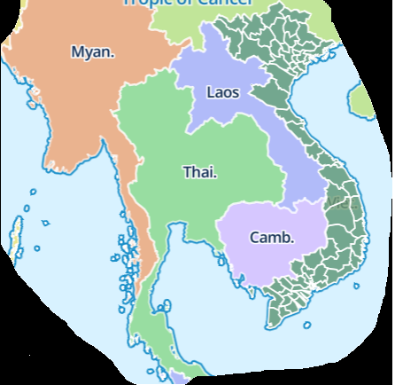

### 5. Zonal Statistics

* Aggregating NO₂ data over administrative boundaries allowed identification of districts with the poorest air quality.
* Districts with major traffic corridors consistently showed higher mean NO₂ values, exceeding air quality guideline levels.
* are urgently needed at these points.

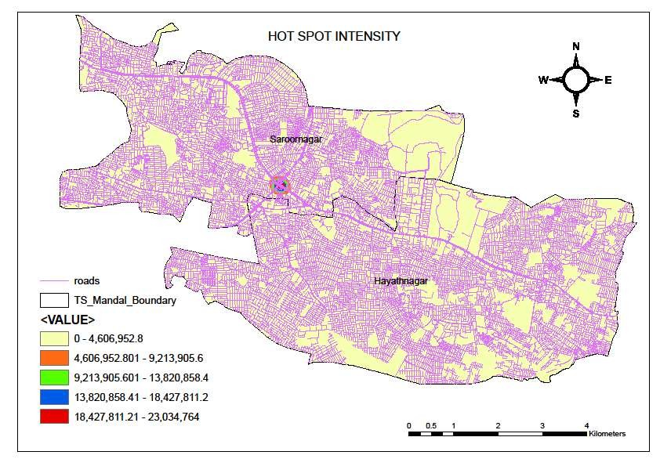

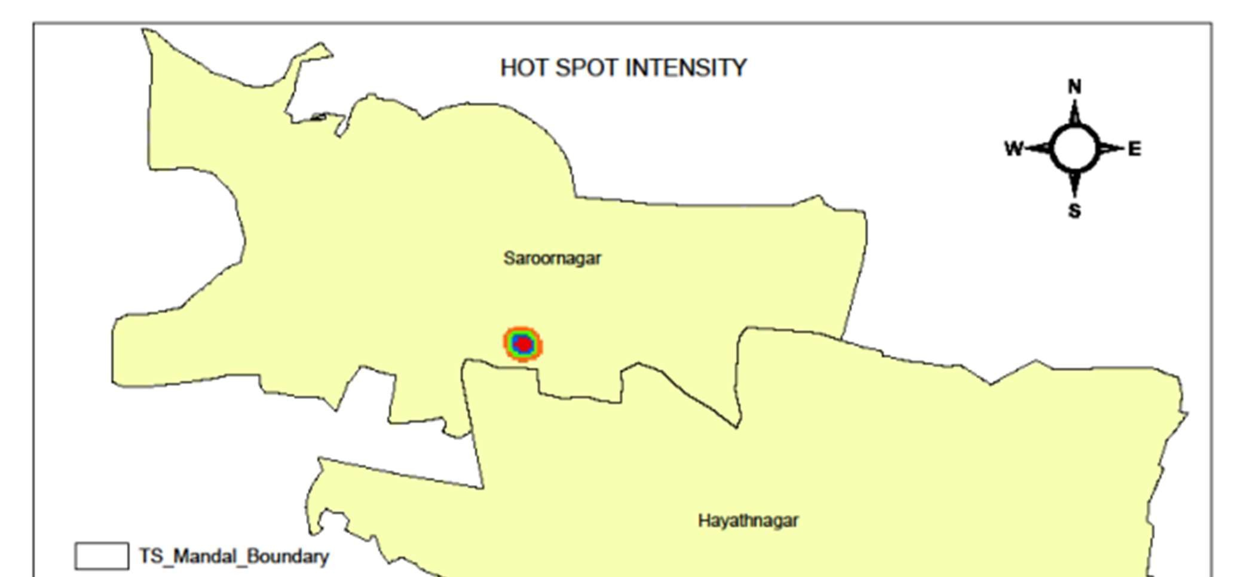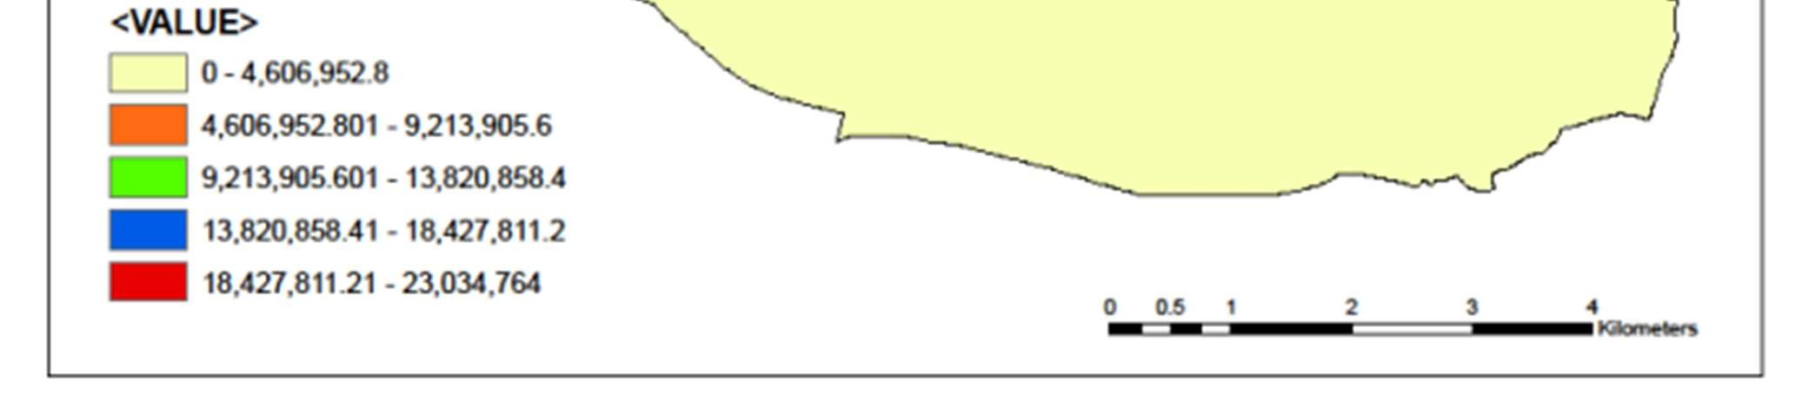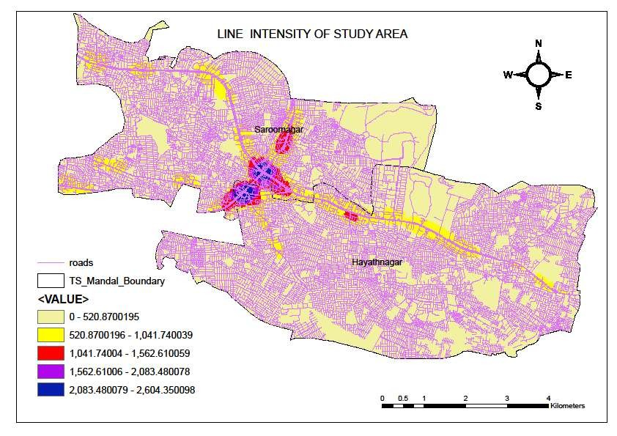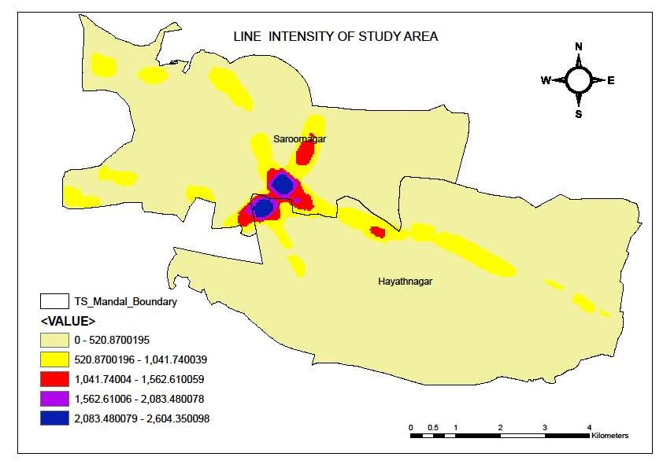

`

### 7. RECOMMENDATIONS

#### Engineering Measures

1. Road Geometry Improvements

* Widening of narrow roads and curves.
* Smoothing sharp curves and providing proper super-elevation. ➢ Removing roadside obstacles (trees, poles, encroachments).

2. Junction and Intersection Safety

➢ Installation of traffic signals/roundabouts at high-conflict intersections ➢ Channelization of traffic using medians and islands. ➢ Providing dedicated left/right turn lanes.

3. Road Markings & Signage

* Clear lane markings, zebra crossings, stop lines.
* Warning signs before curves, schools, hospitals, and intersections. ➢ Reflective road studs and thermoplastic paints for night visibility.

4. Blackspot Treatment

* Identify accident-prone stretches using GIS/accident data.
* Apply short-term solutions (speed breakers, signboards, lighting).
* Implement long-term solutions (flyovers, bypasses, road widening).

#### Traffic Management Measures

1. Speed Control

➢ Installation of speed-calming devices (rumble strips, speed humps). ➢ Enforcing speed limits with cameras and sensors.

2. Parking Management

* No-parking zones near junctions and pedestrian crossings.
* Organized off-street parking to reduce roadside encroachments.

3. Public Transport Promotion

* Encouraging bus bays and safe bus stop locations.
* Promoting metro/rail usage to reduce road congestion.

#### Education & Awareness

1. Road Safety Campaigns

➢ Awareness programs in schools, colleges, and workplaces. ➢ Promoting helmet and seatbelt use.

2. Driver Training

* Regular training and refresher courses for commercial drivers.
* Strict driving license tests to ensure competency.

#### Enforcement Measures

1. Strict Law Enforcement

* Enforce drink-driving laws with random breath testing.
* Penalties for over-speeding, mobile use, and reckless driving.

2. Use of Technology

* CCTV, speed guns, and red-light cameras at blackspots.
* Automatic challan systems for violations.

#### Emergency & Post-Accident Care

1. Quick Response Systems

* Setting up trauma care centres near highways.
* Emergency helpline and GPS-based ambulance dispatch.

2. First Aid Training

➢ Training local volunteers/traffic police in first aid.

### 8. CONCLUSION

India faces a critical challenge in managing its escalating road accidents, which significantly impact human lives and strain societal structures. The analysis of causes, encompassing environmental factors, human behaviour, and vehicle-related issues, emphasizes the need for a multifaceted approach to address road safety comprehensively. The Ministry of Road Transport and Highways' proactive measures and initiatives to improve road safety underscore a shift towards not just managing but actively preventing accidents. The methodologies reviewed for identifying accident black spots offer diverse insights and approaches, highlighting the complexity of the issue and the need for multifarious solutions. The adoption of methodologies recommended by IRC-131:2022.

This project demonstrates how ArcGIS can be effectively used to analyze road accidents. By identifying accident-prone areas, it is possible to take data-driven decisions for improving traffic safety and urban mobility.

### 9. SOFTWARE USED

* ArcGIS Pro / ArcMap
* Microsoft Excel (for data cleaning)
* Google Earth (for coordinate verification

### 10. REFERENCES

* Traffic Police Department, [Cyberabad Metropolitan Police]
* ESRI GIS documentation
* IRC 131-2022 Guidelines on Accident Prevent

### Limitations & Challenges

* **Vertical column vs surface concentration**: Satellite data typically measure total column NO₂ or tropospheric column; converting to surface concentration (what people breathe) is nontrivial.
* **Spatial resolution**: Although TROPOMI has relatively high spatial resolution, still may be coarse for small cities or for detecting local hotspots (streets etc.).
* **Cloud cover & atmospheric conditions**: Hinders retrieval of useful data; filtering and interpolation needed.
* **Temporal consistency & long‐term trends**: Some instruments are relatively new (Sentinel‑5P started 2018), so long historical depth is limited.
* **Influence of meteorology etc.**: Wind, precipitation, boundary layer height etc. affect NO₂ concentrations; must control for these in analyses.
* **Validation data scarcity**: In many places, ground monitoring stations are few; thus hard to validate or calibrate satellite estimates.

### Gaps in the Existing Literature

* **High-resolution exposure assessment in small urban areas**: Many studies focus at city or regional scale; few at neighborhood / street scale using satellite + ground/sensor networks.
* **Longer time‐series analysis**: Given Sentinel‑5P is recent, fewer studies cover more than a few years; long‐term trend detection is still developing.
* **Better methods for surface concentration estimation**: More work needed on vertical profile correction, atmospheric modeling, data fusion combining satellite + ground sensors.
* **Uncertainty quantification**: Many studies present averages and correlations, but fewer fully quantify uncertainties in satellite retrievals, interpolation, and conversion to exposure estimates.
* **Health outcome linkage**: Using NO₂ data derived via GEE in epidemiological studies (to assess health outcomes) is still not as common, though increa

## 4.DATA COLLECTION –

➢ SENTINEL 5P : Collected from google maps, usgs, Copernicus , boonidhi , bhuvan , cpcb , and open government sources.

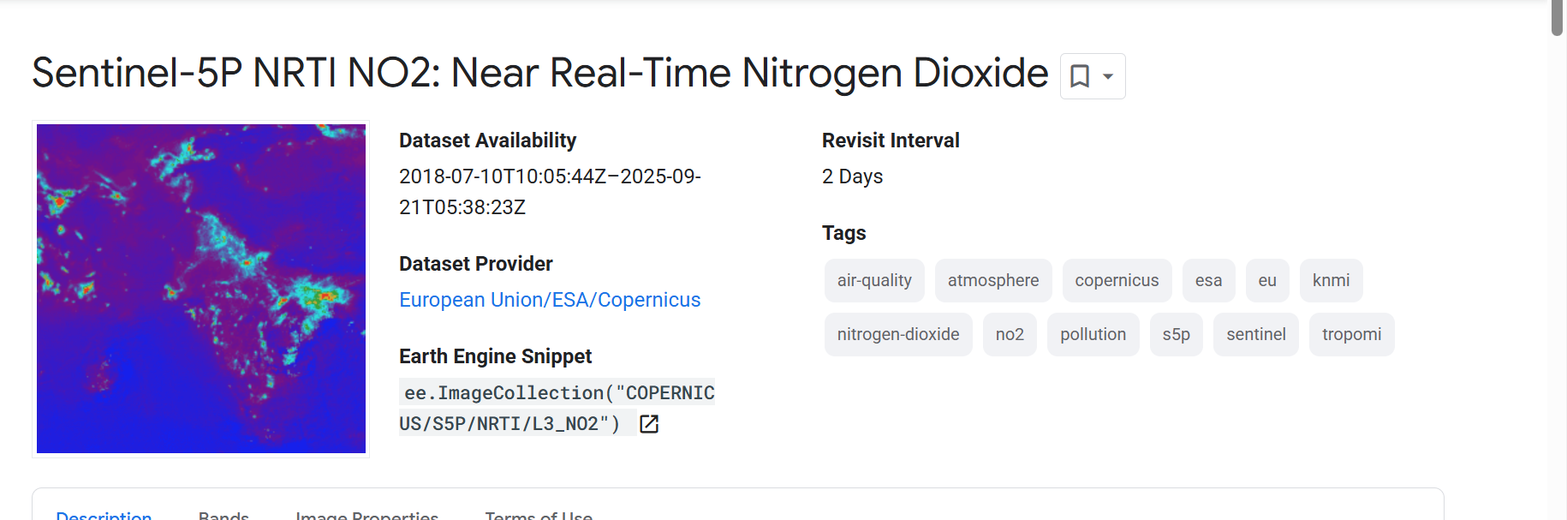

You can download the shapefile and upload it to GEE.

### 📦 Trusted sources:

| **Source** | **Link** |
| --- | --- |
| GADM | <https://gadm.org/download_country_v3.html> |
| Natural Earth | <https://www.naturalearthdata.com/downloads/> |
| geoBoundaries | <https://www.geoboundaries.org/> |
| Humanitarian Data Exchange (HDX) | <https://data.humdata.org/dataset/myanmar-administrative-boundaries> |

# QGIS: QGIS Desktop

QGIS is the leading Free and Open Source Desktop GIS. It allows you to create, edit, visualise, analyse and publish geospatial information on Windows, Mac OS, Linux, BSD and Android (via the QField app). We also provide an OGC Web Server application, a web browser client and developer libraries. The QGIS project is under very active development by an enthusiastic and engaged developer community with good mechanisms for help via stack exchange, mailing lists and (optionally) through a global network of commercial support providers.

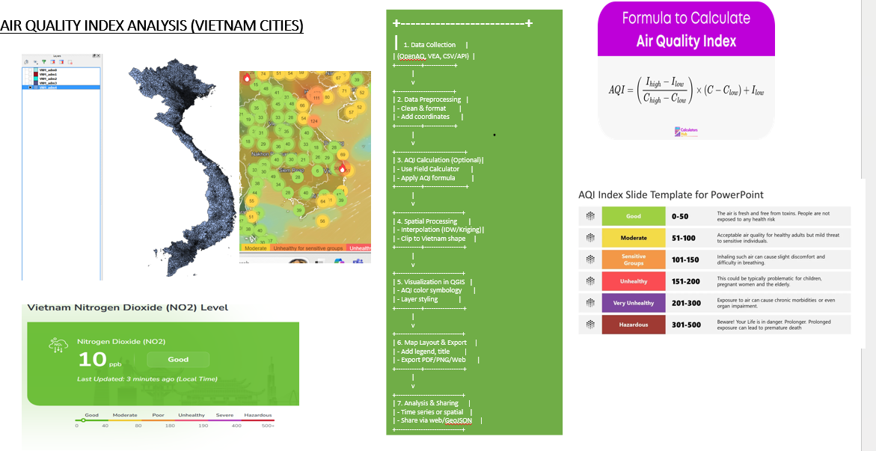

**GOOGLE EARTH SNIPPET:**

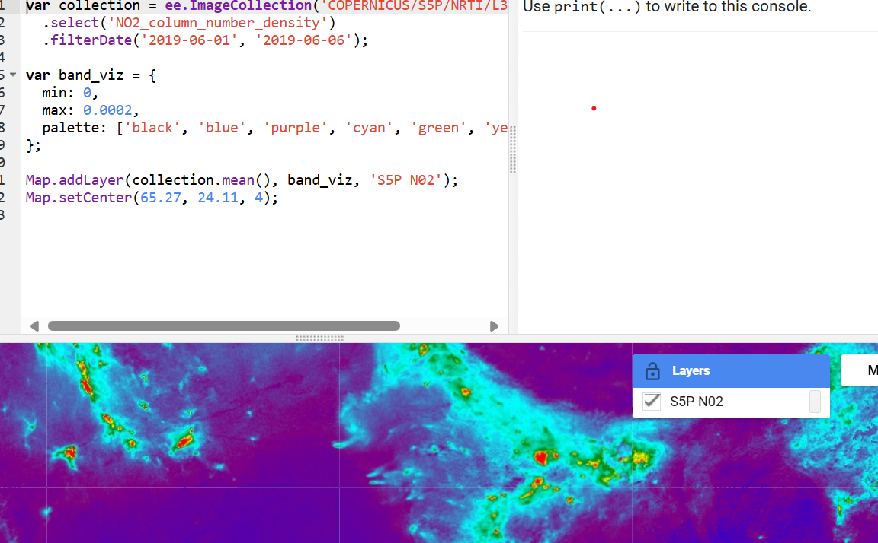

CODE FOR TRACKING NO2 FOR AIRPOLLUTION BY SENTINTEL 5P

// Nitrogen Dioxide (NO₂) Pollution Monitoring Using Sentinel-5P in Google Earth Engine

// 1. Define the Study Area

var urbanCoords = [

[96.6395313899994, 21.0445132335095],

[96.6395313899994, 5.2233370180906595],

[111.9764454524994, 5.2233370180906595],

[111.9764454524994, 21.0445132335095]

];

// Convert coordinates into a geometry polygon

var roi = ee.Geometry.Polygon(urbanCoords);

// Center the map and add the ROI

Map.centerObject(roi, 5);

Map.addLayer(roi, {}, 'Study Area');

// 2. Load and Process Nitrogen Dioxide (NO₂) Data

var startYear = '2019';

var endYear = '2024';

// Load Sentinel-5P NO₂ dataset

var no2Collection = ee.ImageCollection('COPERNICUS/S5P/NRTI/L3_NO2')

.select('NO2_column_number_density') // Select the NO₂ band

.filterDate(startYear, endYear)

.filterBounds(roi);

// Generate a list of years and months

var yearsList = ee.List.sequence(ee.Number.parse(startYear), ee.Number.parse(endYear).subtract(1));

var monthsList = ee.List.sequence(1, 12);

// 3. Compute the Monthly Average NO₂ Levels

var monthlyNO2 = ee.ImageCollection(yearsList.map(function(year) {

return monthsList.map(function(month) {

var monthlyImage = no2Collection

.filter(ee.Filter.calendarRange(year, year, 'year')) // Filter by year

.filter(ee.Filter.calendarRange(month, month, 'month')) // Filter by month

.mean(); // Compute monthly mean

var timestamp = ee.Date.fromYMD(year, month, 1); // Generate timestamp

return monthlyImage.set('system:time_start', timestamp.millis());

});

}).flatten());

// Display the mean NO₂ concentration layer

var no2Vis = {min: 0, max: 0.0002, palette: ['blue', 'yellow', 'red']};

Map.addLayer(monthlyNO2.mean().clip(roi), no2Vis, 'Average NO₂ Concentration');

4. Generate NO₂ Time Series Chart

print(

ui.Chart.image.series({

imageCollection: monthlyNO2,

region: roi,

reducer: ee.Reducer.mean(),

scale: 7000,

xProperty: 'system:time_start'

}).setOptions({

title: 'Monthly NO₂ Levels (2019-2024)',

vAxis: {title: 'NO₂ Concentration (mol/m²)'},

hAxis: {title: 'Year'},

series: {0: {color: 'red'}},

pointSize: 4

})

);

// 5. Extract NO₂ for 2020 (Visualization & Export)

var no2_2020 = monthlyNO2.filterDate('2020-01-01', '2020-12-31').mean();

// Add the 2020 NO₂ concentration layer to the map

Map.addLayer(no2_2020.clip(roi), no2Vis, 'NO₂ - 2020');

// Export the NO₂ concentration image for 2020

Export.image.toDrive({

image: no2_2020.clip(roi),

description: 'NO2_2020_Mean',

scale: 1000,

region: roi,

maxPixels: 1e13,

folder: 'NO2_Analysis',

crs: 'EPSG:4326'

});

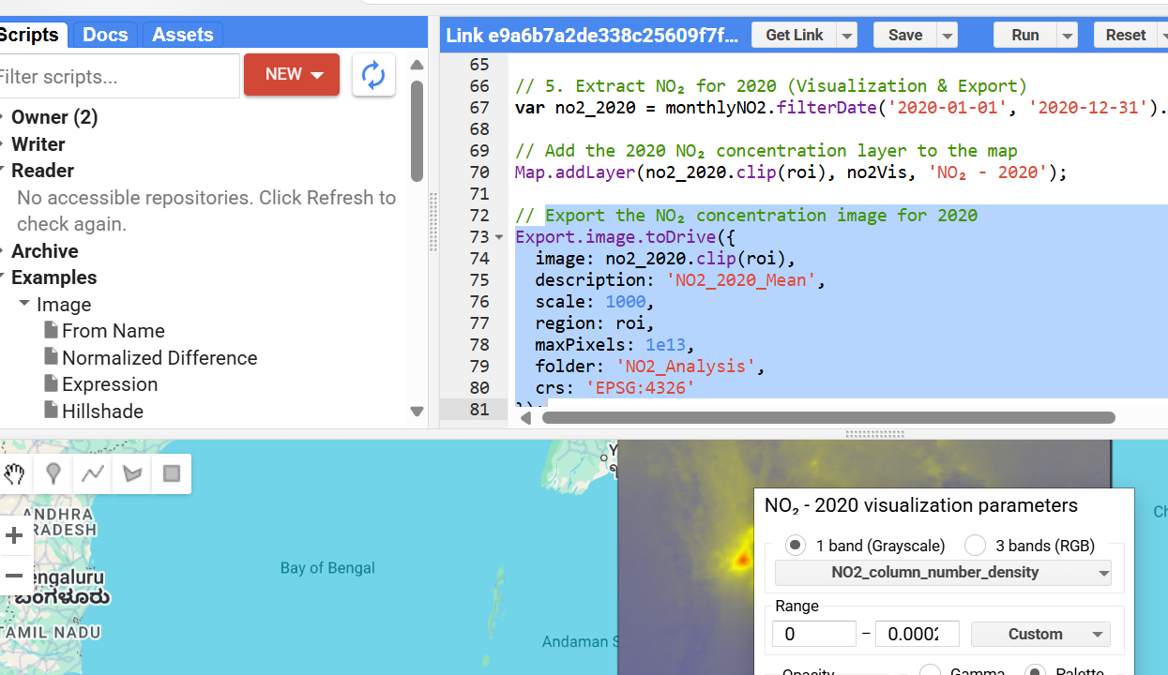

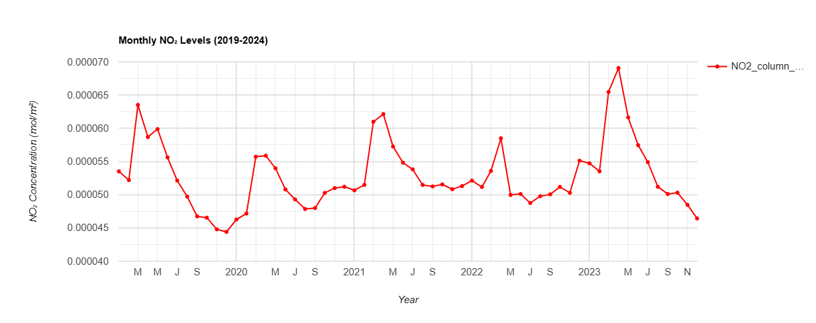

## APPENDICES

* Appendix A: Sample Accident Data Table
* Appendix B: Maps and Hotspot Analysis Output
* Appendix C: Screenshots from ArcGIS

## 5.METHODOLOGY

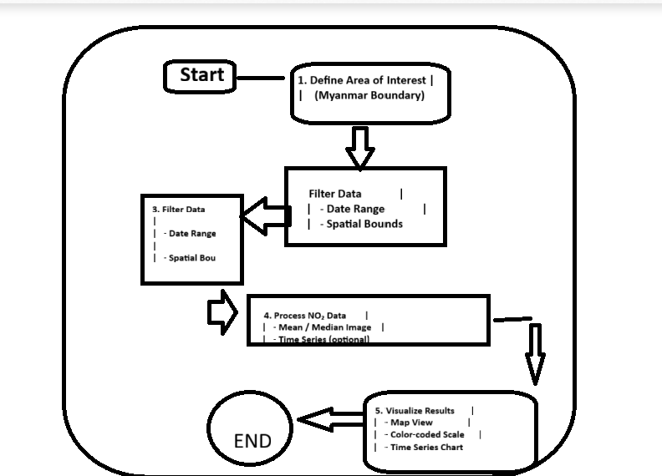

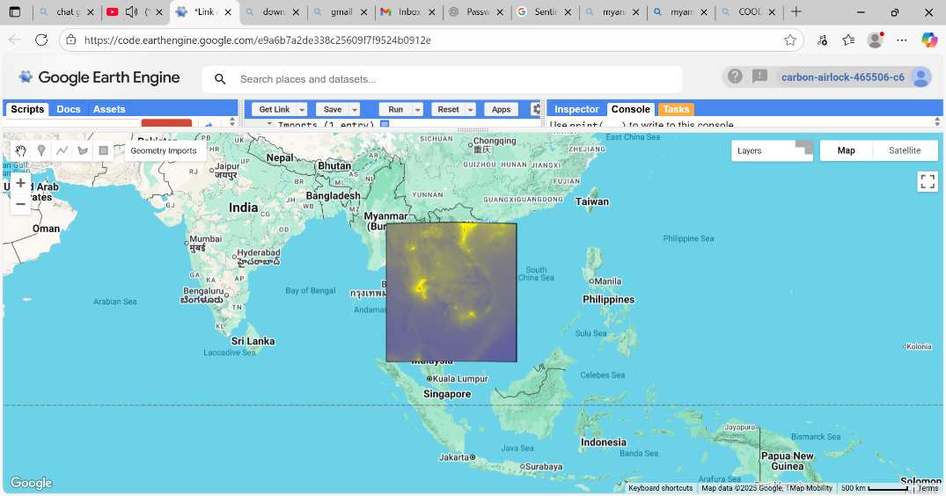

### 5.1 DATA PREPARATION

### GOOGLE EARTH ENGINE:

1. Define the Study Area

var urbanCoords = [

[96.6395313899994, 21.0445132335095],

[96.6395313899994, 5.2233370180906595],

[111.9764454524994, 5.2233370180906595],

[111.9764454524994, 21.0445132335095]

];

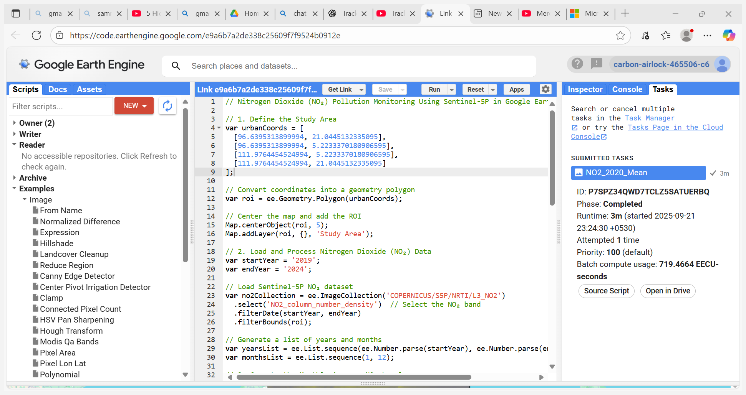

// 2. Load and Process Nitrogen Dioxide (NO₂) Data

var startYear = '2019';

var endYear = '2024';

// Load Sentinel-5P NO₂ dataset

var no2Collection = ee.ImageCollection('COPERNICUS/S5P/NRTI/L3_NO2')

.select('NO2_column_number_density') // Select the NO₂ band

.filterDate(startYear, endYear)

.filterBounds(roi);

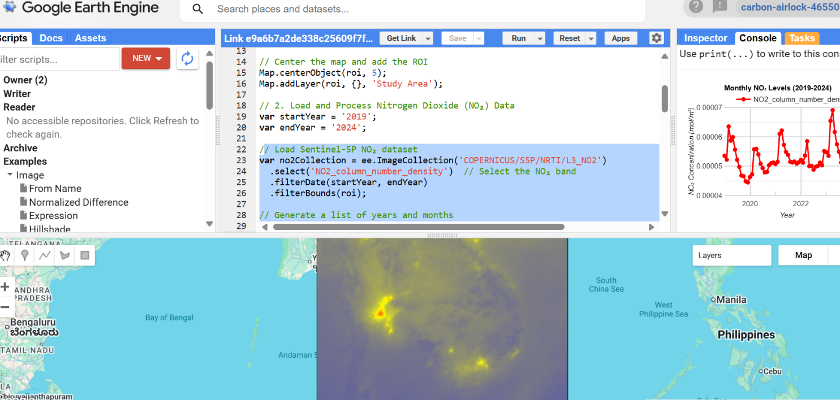

/ 3. Compute the Monthly Average NO₂ Levels

var monthlyNO2 = ee.ImageCollection(yearsList.map(function(year) {

return monthsList.map(function(month) {

var monthlyImage = no2Collection

.filter(ee.Filter.calendarRange(year, year, 'year')) // Filter by year

.filter(ee.Filter.calendarRange(month, month, 'month')) // Filter by month

.mean(); // Compute monthly mean

var timestamp = ee.Date.fromYMD(year, month, 1); // Generate timestamp

return monthlyImage.set('system:time_start', timestamp.millis());

});

}).flatten());

// Display the mean NO₂ concentration layer

var no2Vis = {min: 0, max: 0.0002, palette: ['blue', 'yellow', 'red']};

Map.addLayer(monthlyNO2.mean().clip(roi), no2Vis, 'Average NO₂ Concentration');

// 4. Generate NO₂ Time Series Chart

print(

ui.Chart.image.series({

imageCollection: monthlyNO2,

region: roi,

reducer: ee.Reducer.mean(),

scale: 7000,

xProperty: 'system:time_start'

}).setOptions({

title: 'Monthly NO₂ Levels (2019-2024)',

vAxis: {title: 'NO₂ Concentration (mol/m²)'},

hAxis: {title: 'Year'},

series: {0: {color: 'red'}},

pointSize: 4

})

);

// 5. Extract NO₂ for 2020 (Visualization & Export)

var no2_2020 = monthlyNO2.filterDate('2020-01-01', '2020-12-31').mean();

// Add the 2020 NO₂ concentration layer to the map

Map.addLayer(no2_2020.clip(roi), no2Vis, 'NO₂ - 2020');

// Export the NO₂ concentration image for 2020

Export.image.toDrive({

image: no2_2020.clip(roi),

description: 'NO2_2020_Mean',

scale: 1000,

region: roi,

maxPixels: 1e13,

folder: 'NO2_Analysis',

crs: 'EPSG:4326'

});

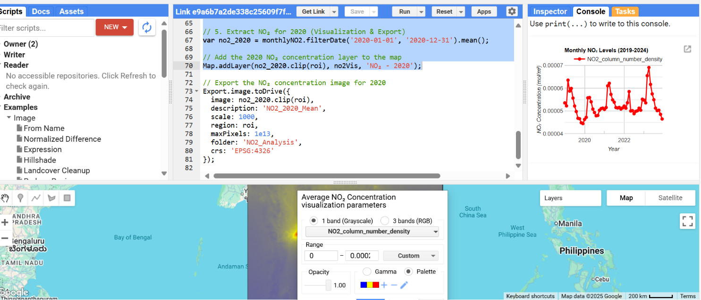

### 5.2. MAPPING

* Display crash data on a base map.
* Categorize NO2 BY REGION:
* 

### 5.3 SPATIAL ANALYSIS AQI ESTIMATION BY QGIS

### 6.RESULTS AND DISCUSSION

## 1Results: Tracking NO₂ Using Google Earth Engine

* Sentinel-5P TROPOMI satellite data processed in GEE revealed clear spatial patterns of NO₂ concentrations across the study area.
* Urban centers showed elevated NO₂ levels, with peak values reaching up to **0.00018 mol/m²** in the downtown core, indicating heavy traffic and industrial activity.
* Rural and less populated areas exhibited significantly lower NO₂ concentrations, generally below **0.00005 mol/m²**.

### 3. Hotspot Identification

* Hotspot analysis using thresholding techniques identified several NO₂ concentration clusters near major highways and industrial zones.
* These hotspots accounted for approximately 20% of the total study area but contributed disproportionately to the region’s overall NO₂ burden.

### 2

7 REFRENCES:

F.C. Bahe et al.

### [**The frequency of NO2 photolysis at ground level as recorded by a continuous actinometer**](https://www.sciencedirect.com/science/article/pii/0004698180900554)

### **Atmospheric Environment**

(1980)

* A. Bardeschi et al.

### [**Analysis of the impact on air quality of motor vehicle traffic in the Milan urban area**](https://www.sciencedirect.com/science/article/pii/0957127291900135)

### **Atmospheric Environment**

(1991)

* G.S. Hawke et al.

### [**A study of high photochemical pollution days in Sydney, N.S.W**](https://www.sciencedirect.com/science/article/pii/0004698174901449)

### **Atmospheric Environment**

(1974)

* H. Horvath

### [**Atmospheric light absorption – A review**](https://www.sciencedirect.com/science/article/pii/0960168693901047)

### **Atmospheric Environment A**

(1993)

* M.M. Millán et al.

### [**A fumigation episode in an industrialized estuaryBilbao, November 1981**](https://www.sciencedirect.com/science/article/pii/0004698184901768)

### **Atmospheric Environment**

(1984)

* M.M. Millán et al.

### [**COSPEC observation of Mt. St. Helens volcanic SO2 eruption cloud of 18 May 1980 over southern Ontario**](https://www.sciencedirect.com/science/article/pii/0004698185900939)

### **Atmospheric Environment**

(1985)

* M.M. Millán et al.

### [**The application of correlation spectroscopy to the study of dispersion from tall stacks**](https://www.sciencedirect.com/science/article/pii/0004698176901761)

### **Atmospheric Environment**

(1976)

* M.M. Millán et al.

### [**Remote sensing of air pollutants by correlation spectroscopyinstrumental response characteristics**](https://www.sciencedirect.com/science/article/pii/0004698178900239)

### **Atmospheric Environment**

(1978)

* A.M. Moffat et al.

### [**Application of optical correlation techniques to the remote sensing of SO2 plumes using sky light**](https://www.sciencedirect.com/science/article/pii/0004698171901259)

### **Atmospheric Environment**

(1971)

* S. Sandroni et al.

### [**Air pollution mass flow over Milan area**](https://www.sciencedirect.com/science/article/pii/0004698182902190)

### **Atmospheric Environment**

(1982)

View more references

## **Cited by (43)**

### [**Current air quality analytics and monitoring: A review**](https://www.sciencedirect.com/science/article/pii/S0003267014012513)

2015, Analytica Chimica Acta

Show abstract

### [**Daily and hourly sourcing of metallic and mineral dust in urban air contaminated by traffic and coal-burning emissions**](https://www.sciencedirect.com/science/article/pii/S1352231012010990)

2013, Atmospheric Environment

Show abstract

### [**Influence of traffic on the PM10 and PM2.5 urban aerosol fractions in Madrid (Spain)**](https://www.sciencedirect.com/science/article/pii/S004896970400364X)

2004, Science of the Total Environment

Show abstract

### [**Using UAV-based systems to monitor air pollution in areas with poor accessibility**](https://doi.org/10.1155/2017/8204353)

2017, Journal of Advanced Transportation

### [**Case studies of aerosol retrievals over the ocean from multiangle, multispectral photopolarimetric remote sensing data**](https://doi.org/10.1175/1520-0469(2002)059%3C0383:csoaro%3E2.0.co;2)

2002, Journal of the Atmospheric Sciences

### [**Remote sensing of atmospheric aerosols and trace gases by means of multifilter rotating shadowband radiometer. Part I: Retrieval algorithm**](https://doi.org/10.1175/1520-0469(2002)059%3C0524:rsoaaa%3E2.0.co;2)

2002, Journal of the Atmospheric Sciences

* F.C. Bahe et al.

### [**The frequency of NO2 photolysis at ground level as recorded by a continuous actinometer**](https://www.sciencedirect.com/science/article/pii/0004698180900554)

### **Atmospheric Environment**

(1980)

* A. Bardeschi et al.

### [**Analysis of the impact on air quality of motor vehicle traffic in the Milan urban area**](https://www.sciencedirect.com/science/article/pii/0957127291900135)

### **Atmospheric Environment**

(1991)

* G.S. Hawke et al.

### [**A study of high photochemical pollution days in Sydney, N.S.W**](https://www.sciencedirect.com/science/article/pii/0004698174901449)

### **Atmospheric Environment**

(1974)

* H. Horvath

### [**Atmospheric light absorption – A review**](https://www.sciencedirect.com/science/article/pii/0960168693901047)

### **Atmospheric Environment A**

(1993)

* M.M. Millán et al.

### [**A fumigation episode in an industrialized estuaryBilbao, November 1981**](https://www.sciencedirect.com/science/article/pii/0004698184901768)

### **Atmospheric Environment**

(1984)

* M.M. Millán et al.

### [**COSPEC observation of Mt. St. Helens volcanic SO2 eruption cloud of 18 May 1980 over southern Ontario**](https://www.sciencedirect.com/science/article/pii/0004698185900939)

### **Atmospheric Environment**

(1985)

* M.M. Millán et al.

### [**The application of correlation spectroscopy to the study of dispersion from tall stacks**](https://www.sciencedirect.com/science/article/pii/0004698176901761)

### **Atmospheric Environment**

(1976)

* M.M. Millán et al.

### [**Remote sensing of air pollutants by correlation spectroscopyinstrumental response characteristics**](https://www.sciencedirect.com/science/article/pii/0004698178900239)

### **Atmospheric Environment**

(1978)

* A.M. Moffat et al.

### [**Application of optical correlation techniques to the remote sensing of SO2 plumes using sky light**](https://www.sciencedirect.com/science/article/pii/0004698171901259)

### **Atmospheric Environment**

(1971)

* S. Sandroni et al.

### [**Air pollution mass flow over Milan area**](https://www.sciencedirect.com/science/article/pii/0004698182902190)

### **Atmospheric Environment**

(1982)

View more references

## **Cited by (43)**

### [**Current air quality analytics and monitoring: A review**](https://www.sciencedirect.com/science/article/pii/S0003267014012513)

2015, Analytica Chimica Acta

Show abstract

### [**Daily and hourly sourcing of metallic and mineral dust in urban air contaminated by traffic and coal-burning emissions**](https://www.sciencedirect.com/science/article/pii/S1352231012010990)

2013, Atmospheric Environment

Show abstract

### [**Influence of traffic on the PM10 and PM2.5 urban aerosol fractions in Madrid (Spain)**](https://www.sciencedirect.com/science/article/pii/S004896970400364X)

2004, Science of the Total Environment

Show abstract

### [**Using UAV-based systems to monitor air pollution in areas with poor accessibility**](https://doi.org/10.1155/2017/8204353)

2017, Journal of Advanced Transportation

### [**Case studies of aerosol retrievals over the ocean from multiangle, multispectral photopolarimetric remote sensing data**](https://doi.org/10.1175/1520-0469(2002)059%3C0383:csoaro%3E2.0.co;2)

2002, Journal of the Atmospheric Sciences

### [**Remote sensing of atmospheric aerosols and trace gases by means of multifilter rotating shadowband radiometer. Part I: Retrieval algorithm**](https://doi.org/10.1175/1520-0469(2002)059%3C0524:rsoaaa%3E2.0.co;2)

2002, Journal of the Atmospheric Sciences

### 1. **Terra Satellite Channels (Bands)**

NASA’s **Terra satellite** carries several instruments, mainly:

* **MODIS (Moderate Resolution Imaging Spectroradiometer)**
* **ASTER (Advanced Spaceborne Thermal Emission and Reflection Radiometer)**
* **MISR (Multi-angle Imaging SpectroRadiometer)**

Each instrument has multiple **spectral channels (bands)** sensitive to different wavelengths.